|  |
| --- |
| 1. User will select the Product Type as Work Visa Insurance and select the policy Type as Master  2. User will click the Create Master Button |
|
|
|

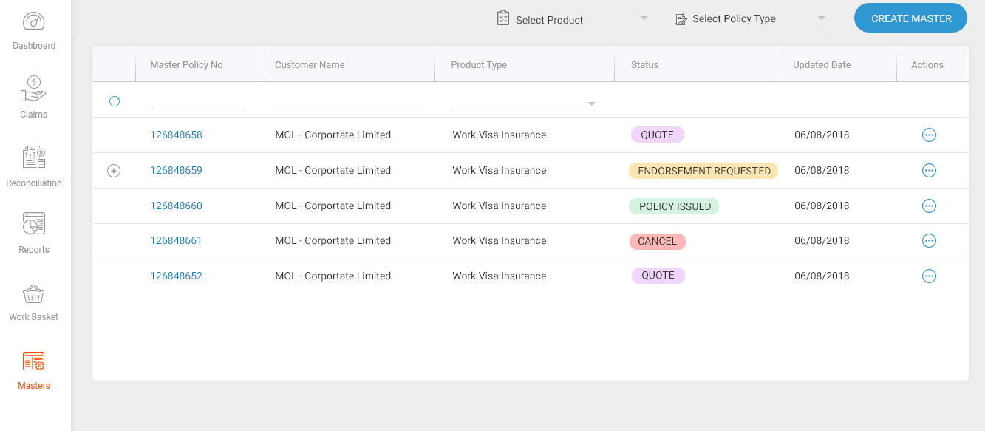

Queries

Where will the Product Type and the Policy Type values get populated from?

3. Once the user clicks the Create Master Button, the following screen shows up

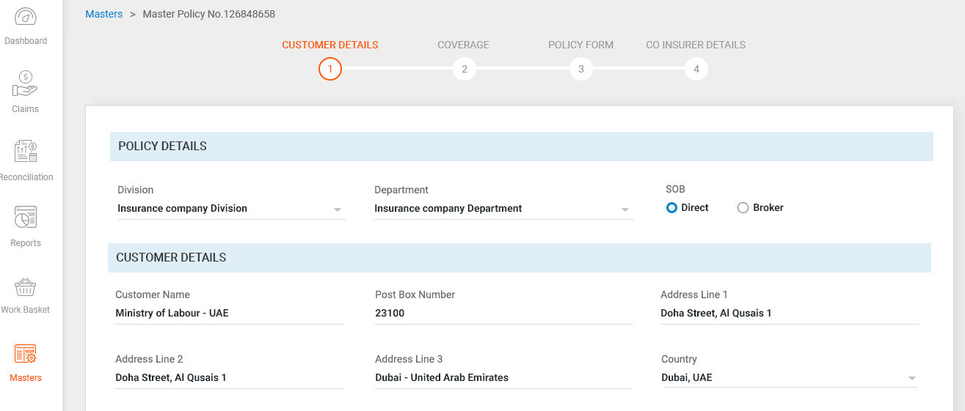

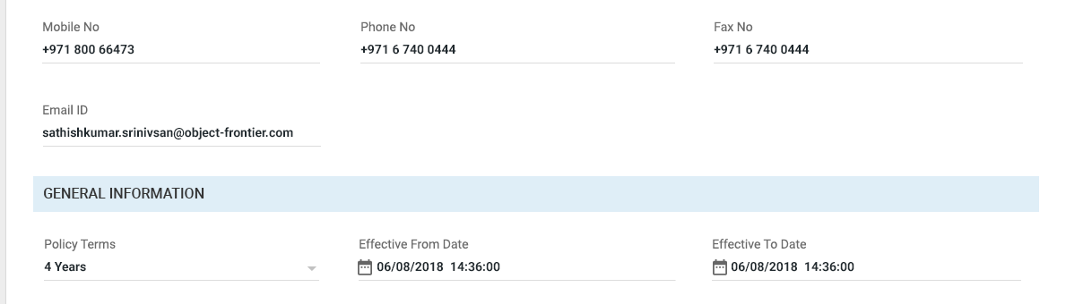

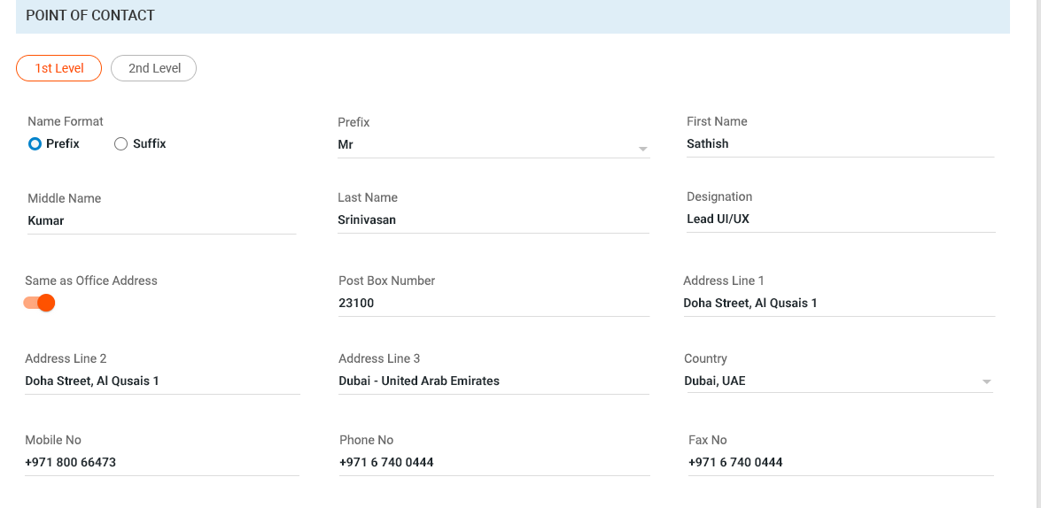

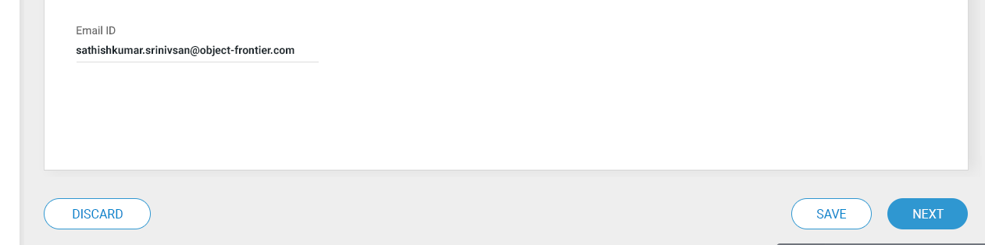

User has to enter the fields in the customer detail screen

4. User has to enter the Policy details, Customer details, General Information, Point of Contact (1st Level, 2nd Level)

5. Once all the details are entered, user has to save the changes by clicking the SAVE Button. We can have the SAVE button at the last page (Co-Insurer Details Page).The user edits should persist across page navigation's.

6. If user wants to discard the changes, user has to click the discard button. The discard will reset all the unsaved entries. We can have the DISCARD button in the last page.

7. There will be a NEXT button to take us to the next page

Please refer the sheet below for the field validations



Queries

1. Where will the Drop down list details for Division and Department come from ?

2. When the user clicks SOB Direct or Broker, will there be any difference in the set of fields shown in the UI ?

3. Where will the Policy terms drop down in General Information section pick the value from? Also what will be the possible values?

4. How will the 1st level and 2nd level contact be shown in UI, Are they tabs?

The next page is the coverage section which is shown below

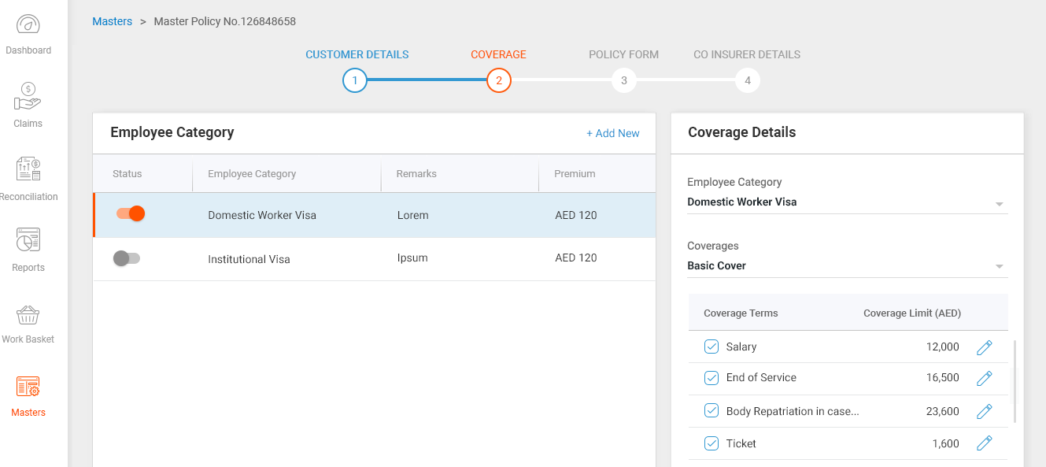

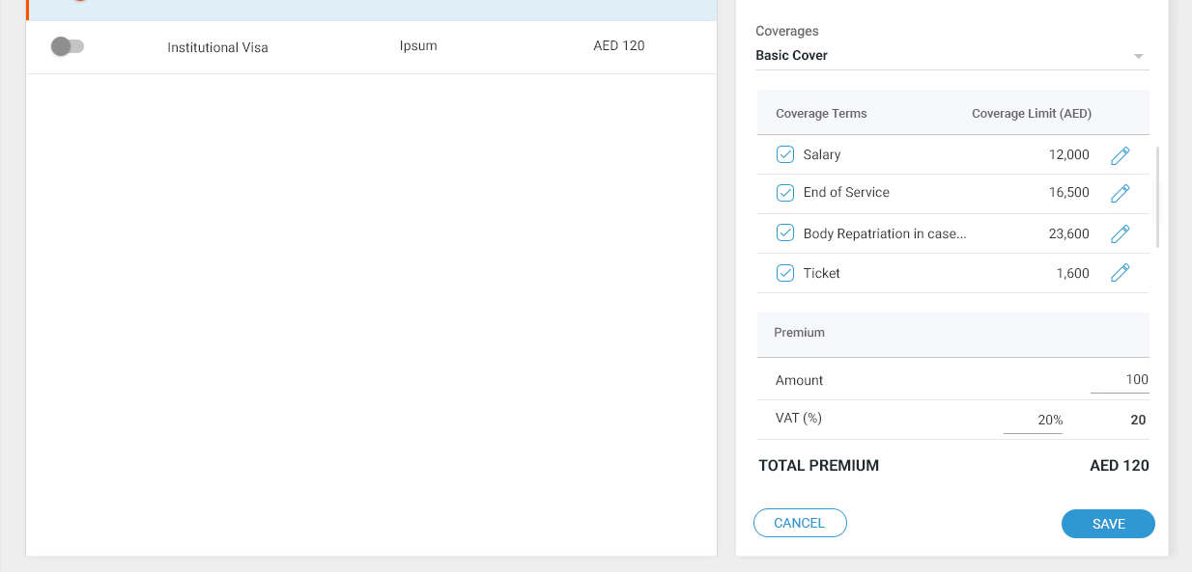

1. When the user is done with the customer details screen, he will click the NEXT Button which will take him to the Coverage Section Page

2. User will try to add a new Employee category by clicking the "Add New" Link

3. When the "Add New" link is clicked, there will be a new Coverage Details section that will be shown in the right. The user can select an Employee category in the list, edit the coverage details (Terms, VAT) and save the category.

4. The newly saved category will be listed in the category section.

5. When there are multiple categories created, selecting a row will display the corresponding coverage details.

6. Clicking on the CANCEL button would discard the employee category creation.

7. Once all the details are entered, user has to save the changes by clicking the SAVE Button. We can have the SAVE button at the last page (Co-Insurer Details Page). The user edits should persist across page navigation's.

8. If user wants to discard the changes, he has to click the discard button, which will reset all the unsaved entries.

9. There will be a NEXT button to take us to the next page.

Please refer the below sheet for Coverage based validations



Queries

1. What are the covers available for an employee category?
2. What are all the default/Important coverage Terms for the Employee?
3. The Total Amount should be calculated based on the selected coverage terms. Is this right?
4. Any value updated will be reflected in the total premium amount. Need to confirm?

The next page is the Policy Form section, which is shown below

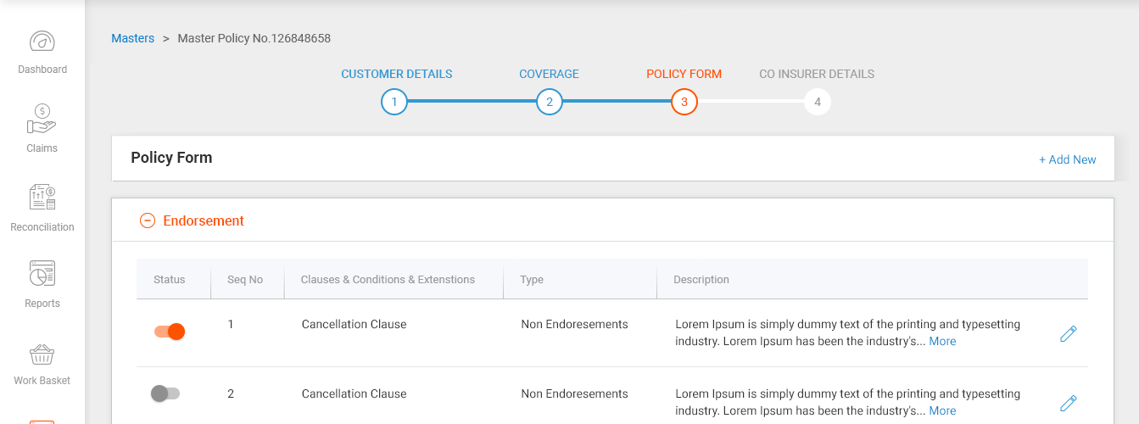

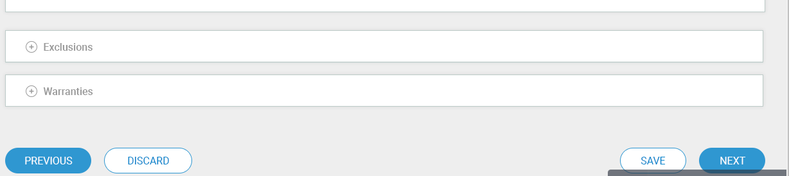

Need a detailed discussion on how this Policy Forms are created and modified?

Please refer the sheet below for the field validations



The next page is the Co-Insurer section Details which is shown below

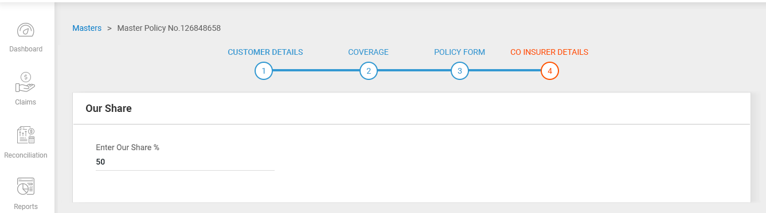

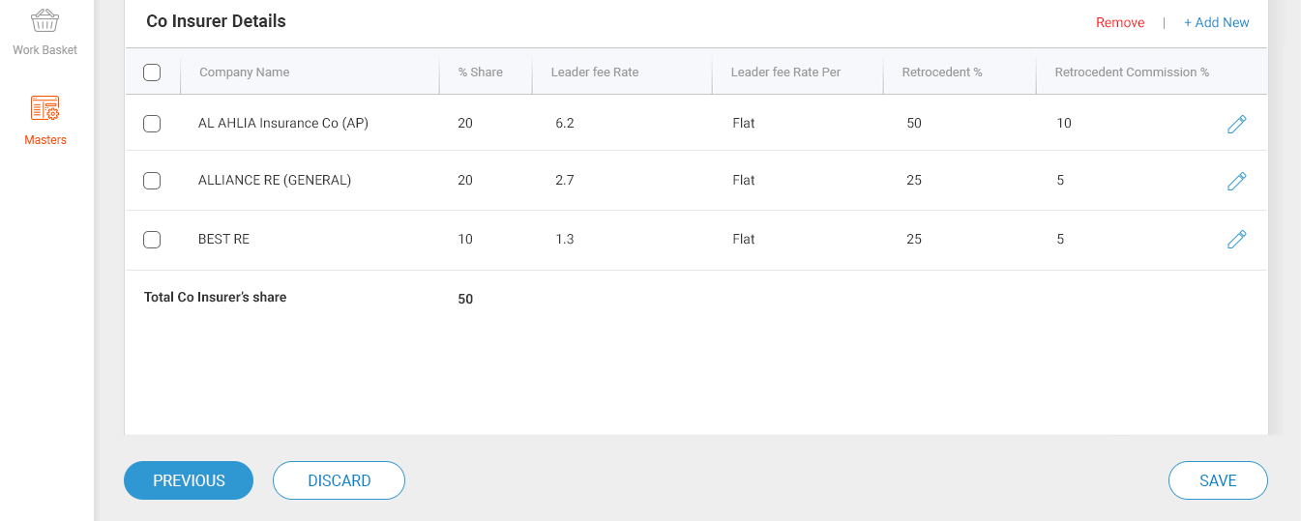

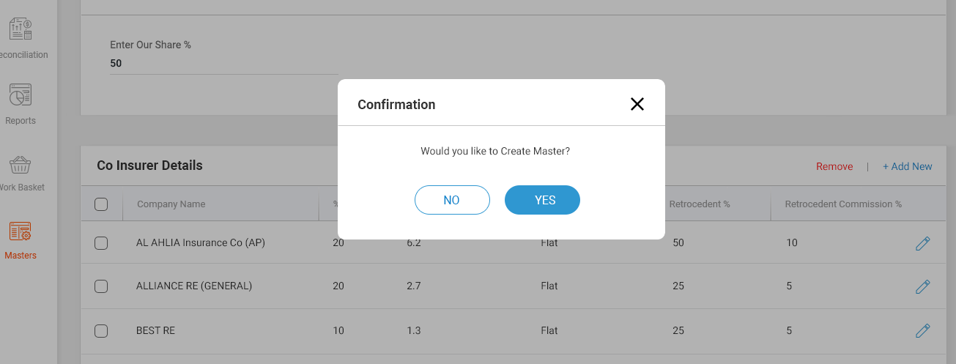

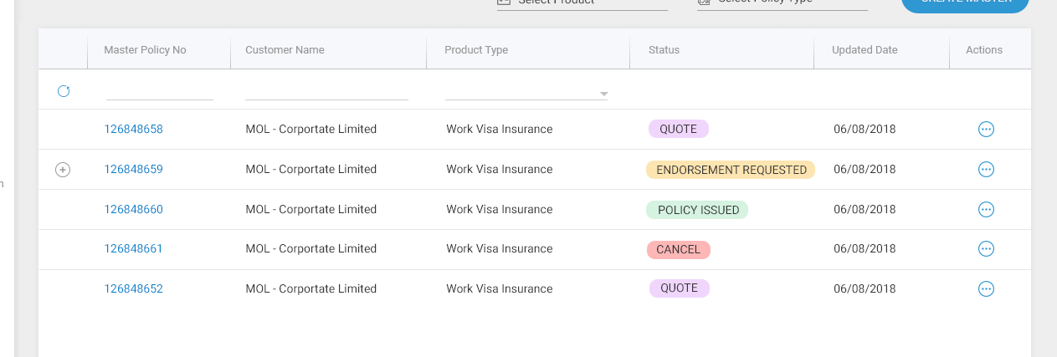

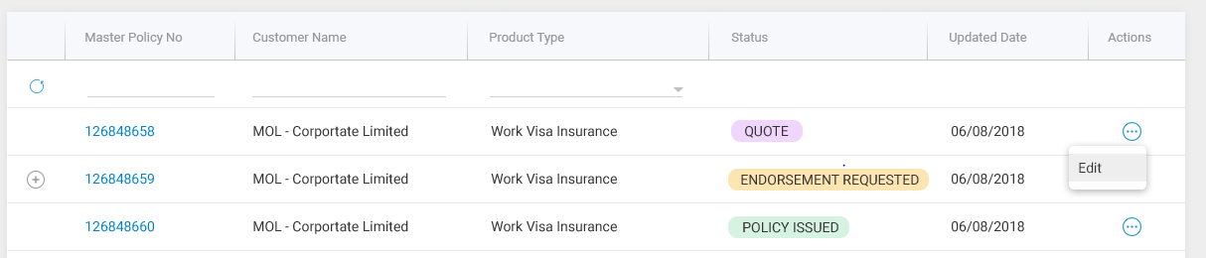

1. when the user is done with the Policy form Screen, he will click the NEXT Button which will take him to the Co-Insurer Section Page

2. User will input the our share details in the field Enter our share %. The First time the user configures the co-Insurers there will be no data.

3. User will click add new to add the new Co- Insurer details in the field Company Name,

%share, Leader fee Rate , Leader Fee Rate per, Retrocedent %,

Retrocedent Commission %, once provided all the details

it will automatically calculated and provided the count in the Total co Insurer's share Field

4. User will able to modify or Remove the Co-Insurer details by selecting the Particular Co-insurer

5. User once update all the co-insurer details, user will click SAVE Button to

save the changes

6.If user wants to discard the changes means, user has to click the discard Button

or user wants to go to previous screen, click PREVIOUS button

7. User Once Updated all the details in the co-insurer screen, user will click SAVE Button

8. Once the SAVE Button is clicked,there will be confirmation pop up which will ask "Would you like to create the Master ?" with YES and NO buttons.

9. If user click NO Button, the master will not be created

10. If the user click YES Button, the Master Policy gets created and it will be shown in the Master listing Screen

11. Master Policy created with the status as 'QUOTE' and will sent for approval

12. Before Approval the user able to edit the Master Policy by clicking the Action Tab in the Master Main Screen

Please refer the sheet below for the field validations



Queries

if the user has to do data entry of the co-insurer details means, what are the percentage of share, Leader fee rate list, leader fee Rate per list, retrocedent % list, Retrocedent Commission % list that exact details information required.

What is the Default Rate per as percentage.

If the user wants to modify the co-insurer details means, which are all fields only the user will able to modify, that field details required.

Master Approval Action , which is shown below

1. User once update and modify the Master policy, the status of Master policy as 'QUOTE', then it will moved automatically to approver for approval.
2. Once user verified and approved the Master Policy Means, the status of the Master Policy is changed into 'POLICY ISSUED' or ACTIVE.

Queries

If the user decline the Master Policy, it will automatically moved to maker user for rectifiable or the policy got terminated completely the Business has to confirm on this

If the user approved the Master Policy means the status will be changed from 'QUOTE' to 'ACTIVE' or status would be as ' POLICY ISSUED'

Master Policy (Endorsement) Action, which is shown below.

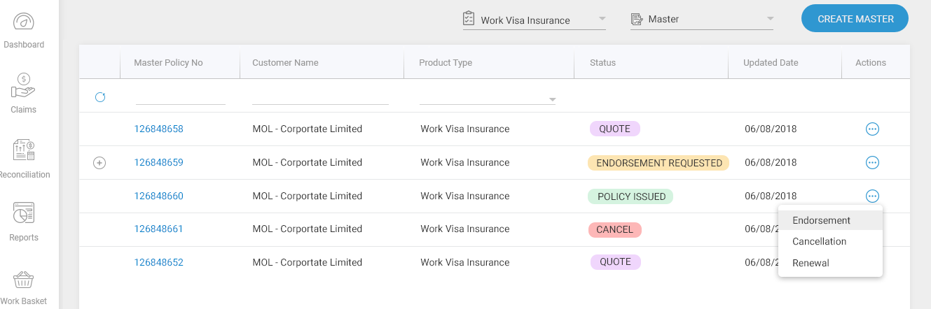

1. In Master Screen, Master Policy No with the status as 'POLICY ISSUED' , User has to click the Action Tab button for that particular Policy and select the Endorsement option in the list.
2. Once select the Endorsement option in that Action Tab, the Endorsement details will be shown, capture the Endorsement Details Like Endorsement-Risk Endorsement , Endorsement Effective From Date, Endorsement Effective To Date, Reason

3. Once capture all the endorsement details and update the policy information as well.

4. Then click SAVE Button to save the changes, once saved the status of that particular Master Policy as ‘Endorsement Requested’ and send for approver.

Queries

After updating the Endorsement details, what are all the policy details needs to updated.

Once all the details updated, we will send again to approver for approve for this endorsement or no need for approval.

if we are sending for an approval, Before approval what will be the status of that particular Master policy.

After approval what will be the status of that particular master policy

Master Policy (Cancellation) Action, which is shown below.



1. In Master Screen, Master Policy No with the status as 'POLICY ISSUED' , User has to click the Action Tab button for that particular Policy and select the Cancellation option in the list.

2. Select the Cancellation Option in that Action Tab, the Cancellation details will be shown, capture the Cancellation details like Endorsement -Cancellation Endorsements, Endorsement Effective from date, Endorsement Effective To date, Reason

3. Once capture all the Cancellation endorsement details, click SAVE Button to save the changes

4. once the cancellation endorsement details saved, it will automatically moved to the status as 'CANCEL' in the Master Policy listing screen.

Queries

After updating the cancellation endorsement details, the user has to send to approver or no need.

Once update and saved directly the status is changed into Cancel.

Need your advise on this

Master Policy (Renewal) Action, which is shown below.















1. In Master Screen, Master Policy No with the status as 'POLICY ISSUED' , User has to click the Action Tab button for that particular Policy and select the Renewal option in the list.

2. Select the Renewal option in that Action Tab, Kindly Note Renewal will start when the Policy Period is about to expire then only the user can renew the Current Master

3. The Policy period is about to expire, the user will click the Action tab and select the Renewal Option

4. User will alter and update the policy details , user can able to alter only the Policy effective from Date To date system will automatically changed.

5. user will alter the customer details, coverage details, policy form details, and co-insurer details, once all the details got altered and updated, then click the overall SAVE Button, the New Master Policy No will be created under that Same Master Policy No like 123658969-01 and the status as 'QUOTE' and again send for approval, once it got approved the status again changed to 'ACTIVE or POLICY ISSUED'

Queries

if the policy period does not expire, the user click for renewal it will not allow to renewal and it will show some pop up.

user ready for renewal for clicking the renewal tab, user what are all the mandatory details he needs to update for renewal of that master policy other the policy effective date.

Once we have saved the renewal policy, the new policy no will be generate and it will be tagged to older policy is it fine.

if the user got save the new renewal policy status changed into QUOTE after approval it will moved to ACTIVE or POLICY ISSUED, what will be the old policy status it will moved to CLOSED or What status you required for that kindly update.